
Prosecution Service of Ukraine
OFFICE OF THE PROSECUTOR GENERAL
13/15 Riznytska St., Kyiv, 01011 fax: (044) 280-26-03
e-mail: office@gp.gov.ua, web: www.gp.gov.ua
USREOU Code 00034051
3 July 2026 No. 10/1/1-4939-17 | To No. ____________ dated ____________
To Attorney
Vladyslav MIFTAKHUTDINOV
v.miftakhutdinov@vbpartners.ua
Your complaint dated 19 June 2026 against the prosecutor's ruling on refusal to satisfy the motion on determination of investigative jurisdiction in criminal proceeding No. 22017000000000272 has been considered.
It has been established that the Main Investigation Directorate of the Security Service of Ukraine is conducting a pre-trial investigation in criminal proceeding No. 22017000000000272 dated 6 July 2017, in particular, on suspicion of V.O. Boguslayev of committing criminal offenses provided for by Part 5 of Art. 191 and Part 3 of Art. 209 of the CC of Ukraine, and O.V. Boguslayev of committing a criminal offense provided for by Part 3 of Art. 209 of the CC of Ukraine.
The prosecutor considered Your motion dated 29 May 2026 No. 20260529/1 on determination of investigative jurisdiction in this criminal proceeding behind the National Anti-Corruption Bureau of Ukraine. Following the results of the consideration, he adopted a ruling on refusal to satisfy it. Grounds for revoking this ruling, provided for by Part 6 of Art. 36 of the CPC of Ukraine, have not been established.
At the same time, I explain that a decision, action or inactivity of a prosecutor may be appealed in the manner provided for by Arts. 303–306 of the CPC of Ukraine.
Deputy  Prosecutor General | 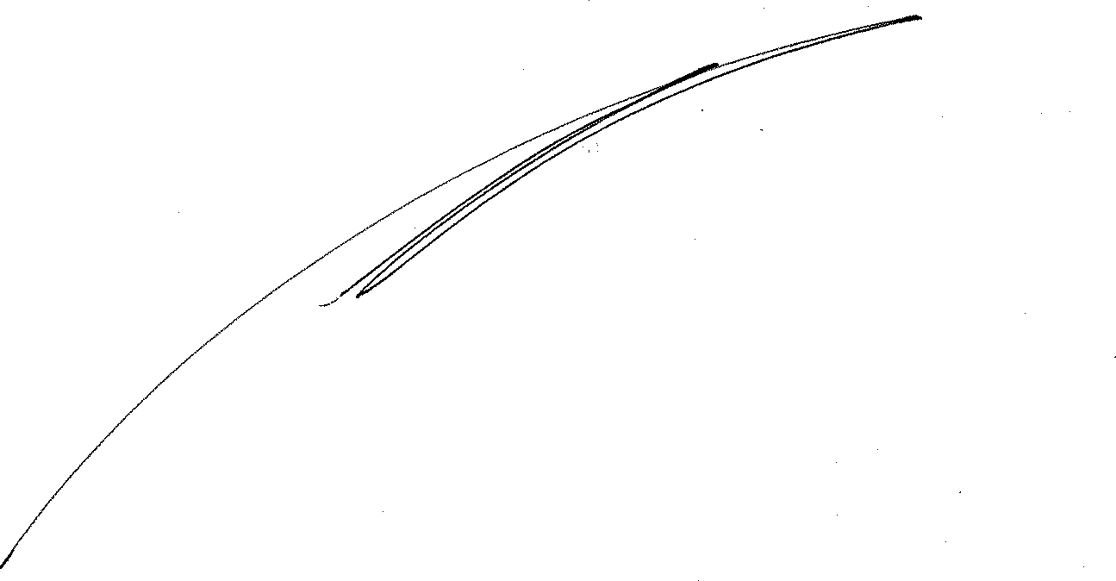  Oleksiy KHOMENKO
